PyPoll

Deliverable 1

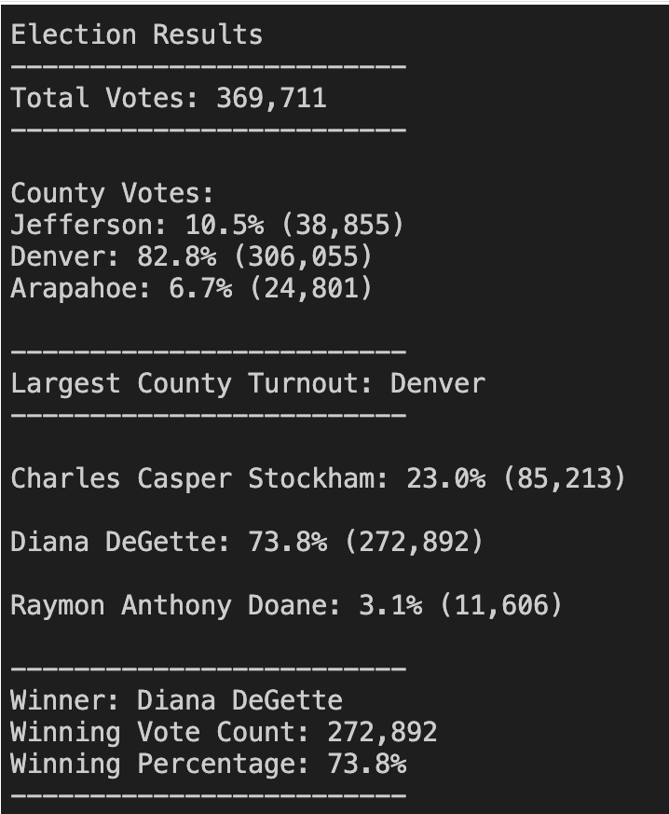

Deliverable 3

* How many votes were cast in this congressional election?
* 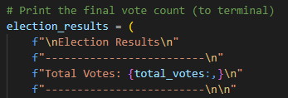
* Provide a breakdown of the number of votes and the percentage of total votes for each county in the precinct.
* 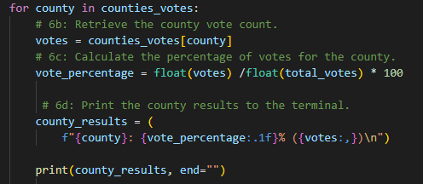
* Which county had the largest number of votes?
* Provide a breakdown of the number of votes and the percentage of the total votes each candidate received.
* 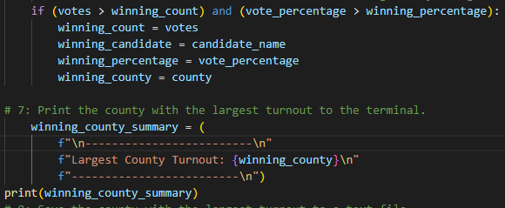
* Which candidate won the election, what was their vote count, and what was their percentage of the total votes?